Pune City

Home About Places

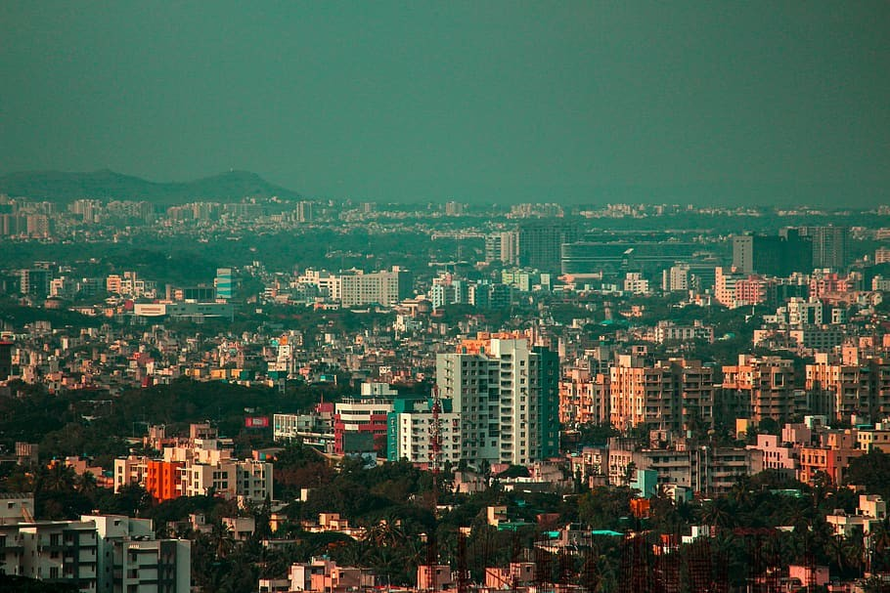

Pune district is located between 17 degrees 54' and 10 degrees 24' North latitude and 73 degrees 19' and 75 degrees 10' East longitude. The district has geographical area of 15.642sq.km.

Pune district is bound by Ahmadnagar district on north-east,Solapur district on the south-east, Satara district on south, Raigad district on the west and Thane district on the northe-west.

**List of Famous Places in Pune**

Shaniwar Wada Dagadusheth Ganpati Mandir Lohagad Fort Aga Khan Palace

Pune district is located between 17 degrees 54' and 10 degrees 24' North latitude and 73 degrees 19' and 75 degrees 10' East longitude. The district has geographical area of 15.642sq.km.

Pune district is bound by Ahmadnagar district on north-east,Solapur district on the south-east, Satara district on south, Raigad district on the west and Thane district on the northe-west.

It is the second largest district in the state and covers 5.10% of the total geographical area of the state. The landscape of Pune district is distributed triangularly in western Maharashtra at the foothills of the Sahyadri Mountains and is divided into three parts: “Ghatmatha”, “Maval” and “Desh”. Pune district forms a part of the tropical monsoon land and therefore shows a significant seasonal variation in temperature as well as rainfall conditions. Climate of the

western region of Pune is cool whereas the eastern part is hot and dry.

Pune district is located between 17 degrees 54' and 10 degrees 24' North latitude and 73 degrees 19' and 75 degrees 10' East longitude. The district has geographical area of 15.642sq.km.

Pune district is bound by Ahmadnagar district on north-east,Solapur district on the south-east, Satara district on south, Raigad district on the west and Thane district on the northe-west.

It is the second largest district in the state and covers 5.10% of the total geographical area of the state. The landscape of Pune district is distributed triangularly in western Maharashtra at the foothills of the Sahyadri Mountains and is divided into three parts: “Ghatmatha”, “Maval” and “Desh”. Pune district forms a part of the tropical monsoon land and therefore shows a significant seasonal variation in temperature as well as rainfall conditions. Climate of the

western region of Pune is cool whereas the eastern part is hot and dry.

Pune district is located between 17 degrees 54' and 10 degrees 24' North latitude and 73 degrees 19' and 75 degrees 10' East longitude. The district has geographical area of 15.642sq.km.

Pune district is bound by Ahmadnagar district on north-east,Solapur district on the south-east, Satara district on south, Raigad district on the west and Thane district on the northe-west.

It is the second largest district in the state and covers 5.10% of the total geographical area of the state. The landscape of Pune district is distributed triangularly in western Maharashtra at the foothills of the Sahyadri Mountains and is divided into three parts: “Ghatmatha”, “Maval” and “Desh”. Pune district forms a part of the tropical monsoon land and therefore shows a significant seasonal variation in temperature as well as rainfall conditions. Climate of the

western region of Pune is cool whereas the eastern part is hot and dry.

Pune district is located between 17 degrees 54' and 10 degrees 24' North latitude and 73 degrees 19' and 75 degrees 10' East longitude. The district has geographical area of 15.642sq.km.

# Shaniwar Wada

Pune district is located between 17 degrees 54' and 10 degrees 24' North latitude and 73 degrees 19' and 75 degrees 10' East longitude. The district has geographical area of 15.642sq.km.

Pune district is bound by Ahmadnagar district on north-east,Solapur district on the south-east, Satara district on south, Raigad district on the west and Thane district on the northe-west.

It is the second largest district in the state and covers 5.10% of the total geographical area of the state. The landscape of Pune district is distributed triangularly in western Maharashtra at the foothills of the Sahyadri Mountains and is divided into three parts: “Ghatmatha”, “Maval” and “Desh”. Pune district forms a part of the tropical monsoon land and therefore shows a significant seasonal variation in temperature as well as rainfall conditions. Climate of the

western region of Pune is cool whereas the eastern part is hot and dry.

Pune district is located between 17 degrees 54' and 10 degrees 24' North latitude and 73 degrees 19' and 75 degrees 10' East longitude. The district has geographical area of 15.642sq.km.

Pune district is bound by Ahmadnagar district on north-east,Solapur district on the south-east, Satara district on south, Raigad district on the west and Thane district on the northe-west.

# Dagadusheth Ganpati Mandir

Pune district is located between 17 degrees 54' and 10 degrees 24' North latitude and 73 degrees 19' and 75 degrees 10' East longitude. The district has geographical area of 15.642sq.km.

It is the second largest district in the state and covers 5.10% of the total geographical area of the state. The landscape of Pune district is distributed triangularly in western Maharashtra at the foothills of the Sahyadri Mountains and is divided into three parts: “Ghatmatha”, “Maval” and “Desh”. Pune district forms a part of the tropical monsoon land and therefore shows a significant seasonal variation in temperature as well as rainfall conditions. Climate of the

western region of Pune is cool whereas the eastern part is hot and dry.

It is the second largest district in the state and covers 5.10% of the total geographical area of the state. The landscape of Pune district is distributed triangularly in western Maharashtra at the foothills of the Sahyadri Mountains and is divided into three parts: “Ghatmatha”, “Maval” and “Desh”. Pune district forms a part of the tropical monsoon land and therefore shows a significant seasonal variation in temperature as well as rainfall conditions. Climate of the

western region of Pune is cool whereas the eastern part is hot and dry.

# Lohagad Fort

Pune district is located between 17 degrees 54' and 10 degrees 24' North latitude and 73 degrees 19' and 75 degrees 10' East longitude. The district has geographical area of 15.642sq.km.

Pune district is bound by Ahmadnagar district on north-east,Solapur district on the south-east, Satara district on south, Raigad district on the west and Thane district on the northe-west.

It is the second largest district in the state and covers 5.10% of the total geographical area of the state. The landscape of Pune district is distributed triangularly in western Maharashtra at the foothills of the Sahyadri Mountains and is divided into three parts: “Ghatmatha”, “Maval” and “Desh”. Pune district forms a part of the tropical monsoon land and therefore shows a significant seasonal variation in temperature as well as rainfall conditions. Climate of the

western region of Pune is cool whereas the eastern part is hot and dry.

# Aga Khan Palace

Pune district is located between 17 degrees 54' and 10 degrees 24' North latitude and 73 degrees 19' and 75 degrees 10' East longitude. The district has geographical area of 15.642sq.km.

Pune district is bound by Ahmadnagar district on north-east,Solapur district on the south-east, Satara district on south, Raigad district on the west and Thane district on the northe-west.

It is the second largest district in the state and covers 5.10% of the total geographical area of the state. The landscape of Pune district is distributed triangularly in western Maharashtra at the foothills of the Sahyadri Mountains and is divided into three parts: “Ghatmatha”, “Maval” and “Desh”. Pune district forms a part of the tropical monsoon land and therefore shows a significant seasonal variation in temperature as well as rainfall conditions. Climate of the

western region of Pune is cool whereas the eastern part is hot and dry.

Pune district is located between 17 degrees 54' and 10 degrees 24' North latitude and 73 degrees 19' and 75 degrees 10' East longitude. The district has geographical area of 15.642sq.km.

It is the second largest district in the state and covers 5.10% of the total geographical area of the state. The landscape of Pune district is distributed triangularly in western Maharashtra at the foothills of the Sahyadri Mountains and is divided into three parts: “Ghatmatha”, “Maval” and “Desh”. Pune district forms a part of the tropical monsoon land and therefore shows a significant seasonal variation in temperature as well as rainfall conditions. Climate of the

western region of Pune is cool whereas the eastern part is hot and dry.